**Project Report 14**

Human Activity Recognition from Smart Phone Data

**NAME: DHIVAKAR.R**

**COURSE: AI and ML**

Question:

Perform activity recognition on the dataset using a hidden markov model. Then perform the same task using a different classification algorithm (logistic regression/decision tree) of your choice and compare the performance of the two algorithms

**Prerequisites**

What things you need to install the software and how to install them:

Python 3.6 This setup requires that your machine has latest version of python. The following url <https://www.python.org/downloads/> can be referred to download python. Once you have python downloaded and installed, you will need to setup PATH variables (if you want to run python program directly, detail instructions are below in how to run software section). To do that check this: <https://www.pythoncentral.io/add-python-to-path-python-is-not-recognized-asan-internal-or-externalcommand/> . Setting up PATH variable is optional as you can also run program without it and more instruction are given below on this topic.

Second and easier option is to download anaconda and use its anaconda prompt to run the commands. To install anaconda check this url <https://www.anaconda.com/download/> You will also need to download and install below 3 packages after you install either python or anaconda from the steps above Sklearn (scikit-learn) numpy scipy if you have chosen to install python 3.6

Dataset Link: Human Activity Recognition with Smartphones

<https://www.kaggle.com/uciml/human-activity-recognition-with-smartphones>

Implementation

Importing the libraries and dataset

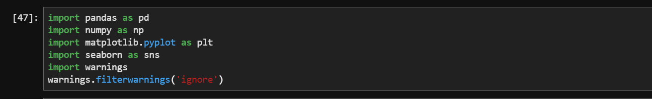

Read the data set

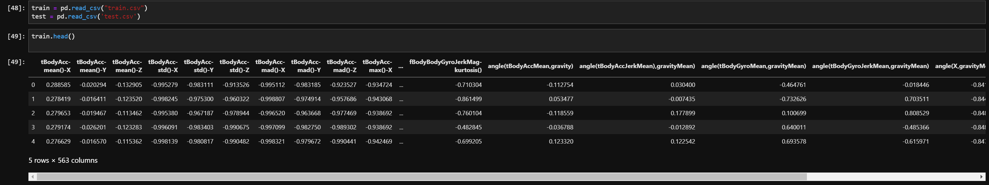

Visualization of data:

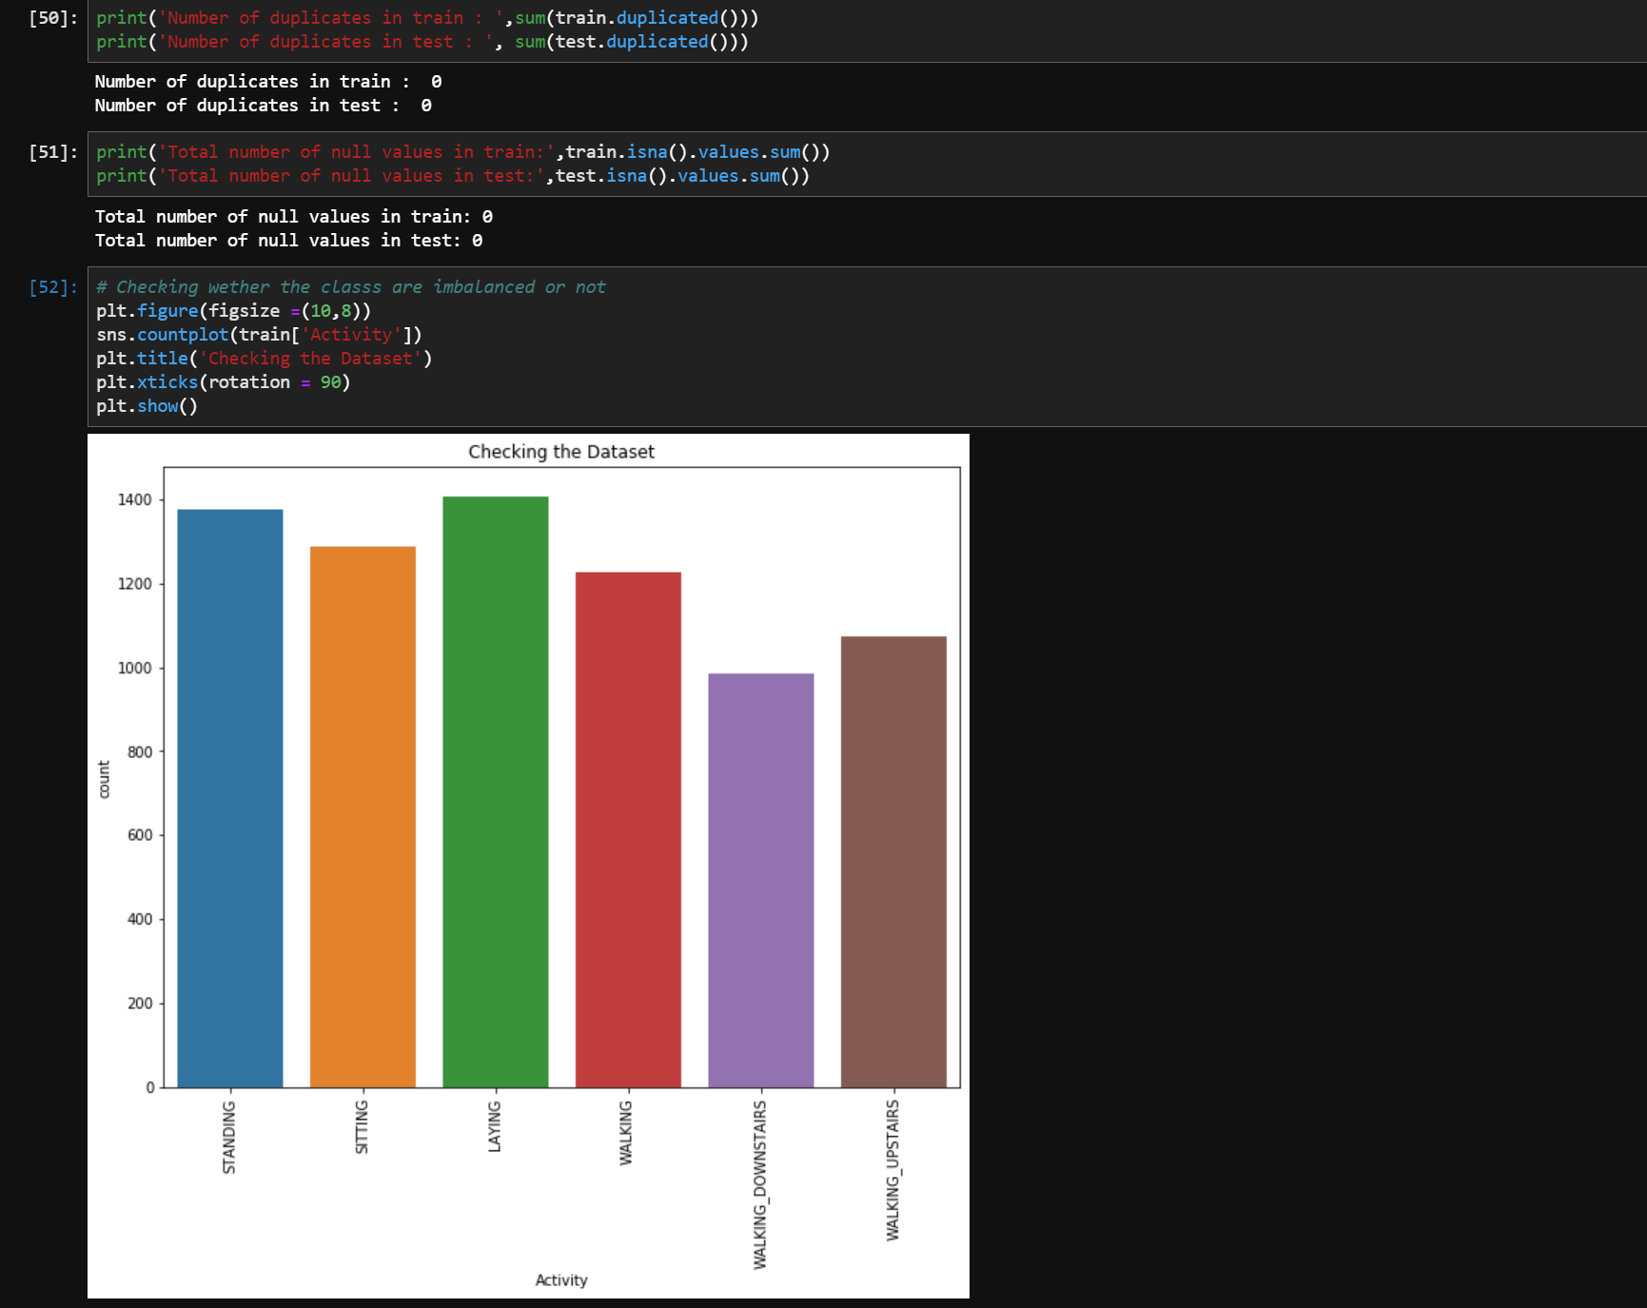

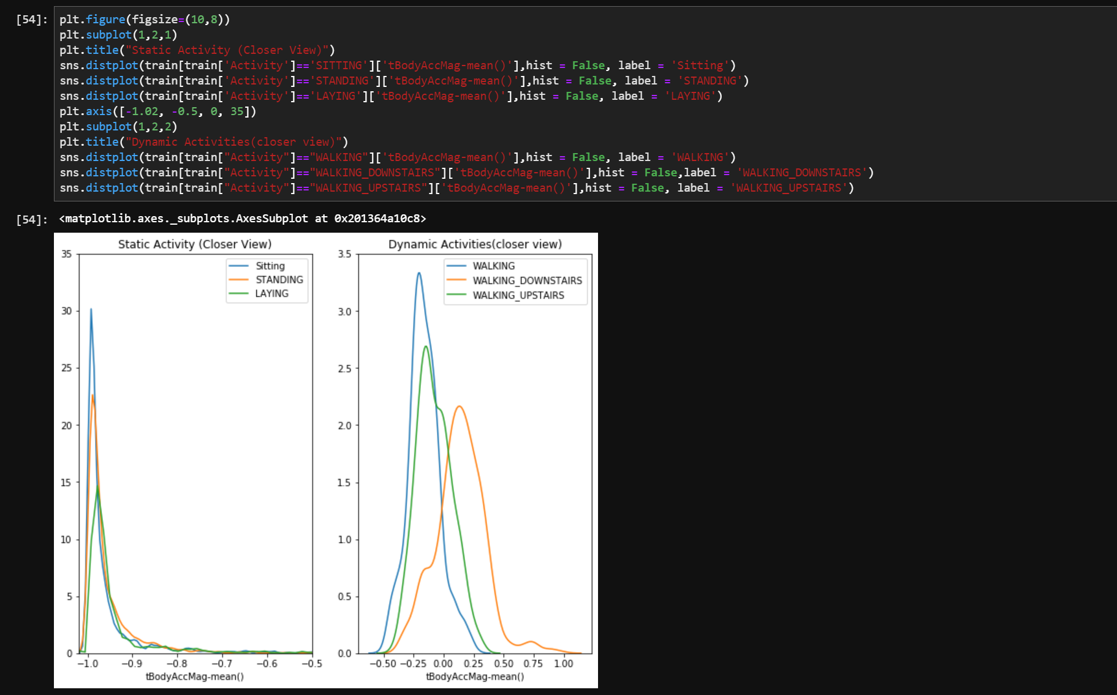

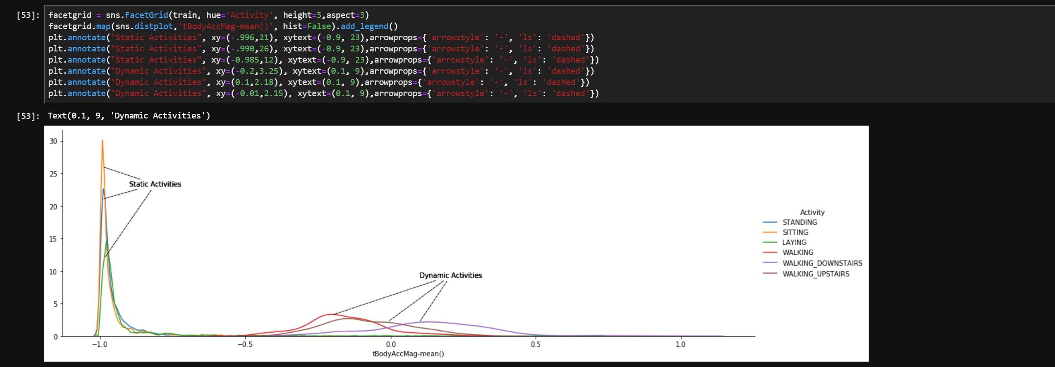

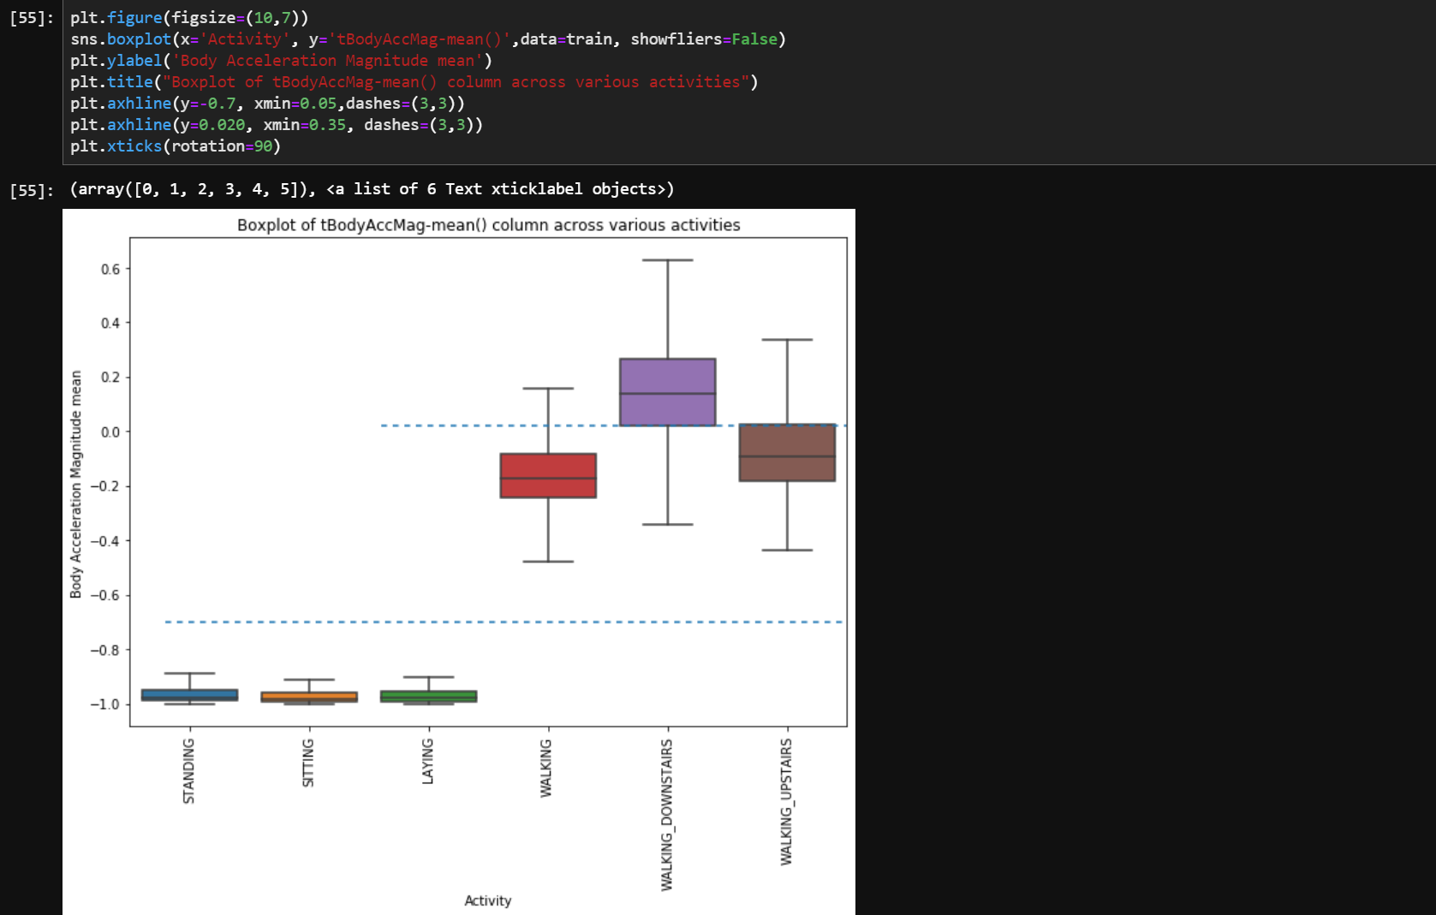

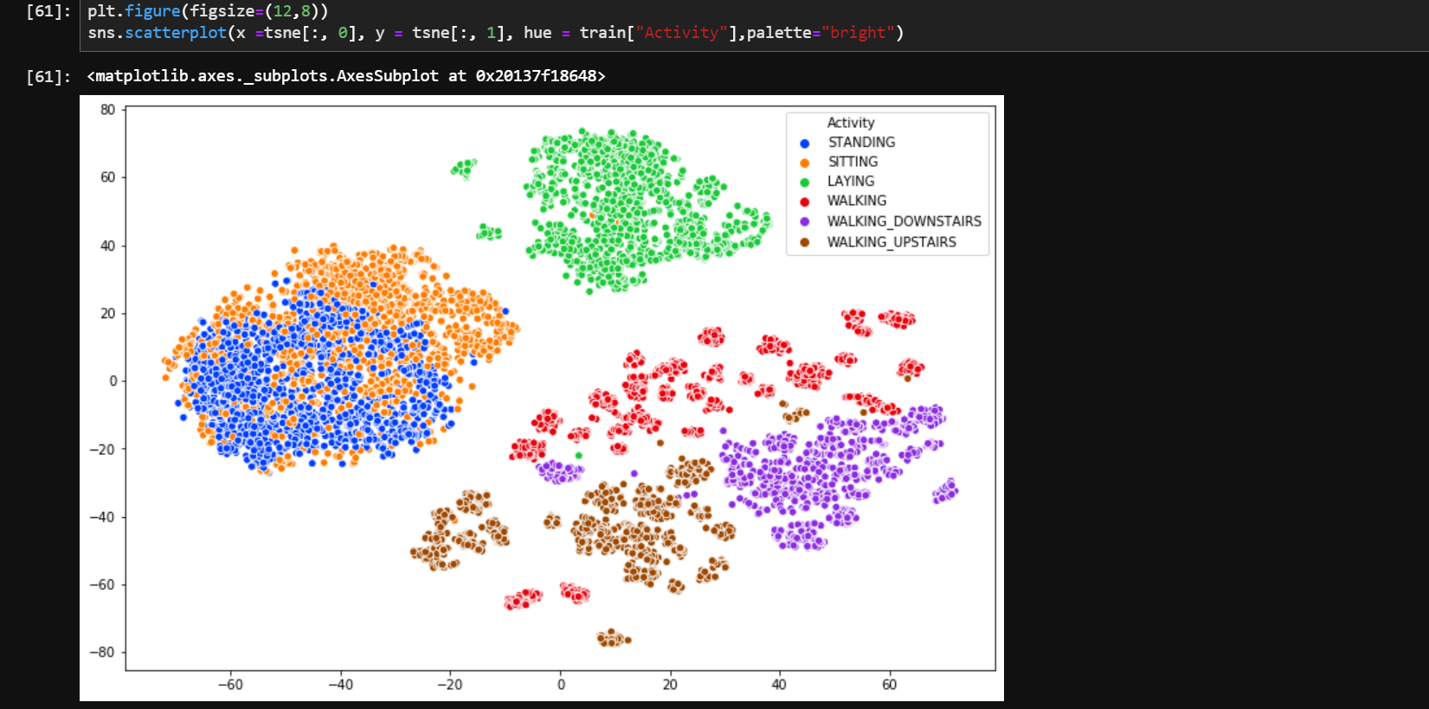

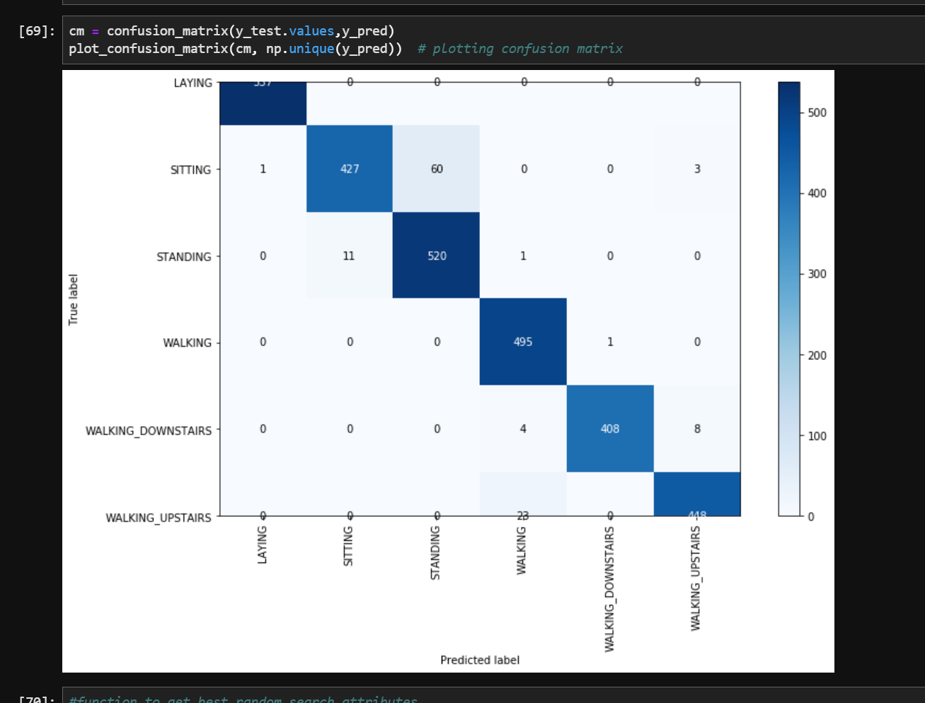

Decision Tree Classifier

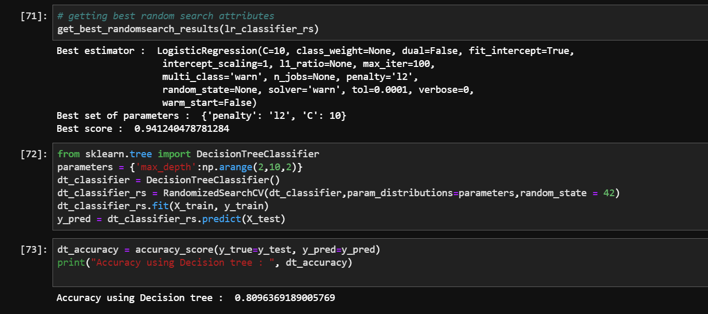

HMM output:

